What's happening?
The new Banner 9 version of Employee Self Service is now available! You may remember at the end of last year we moved from Internet Native Banner (INB), aka Banner 8 to Banner 9. Self Service is the other half of Banner and this is the first piece that is available for use.
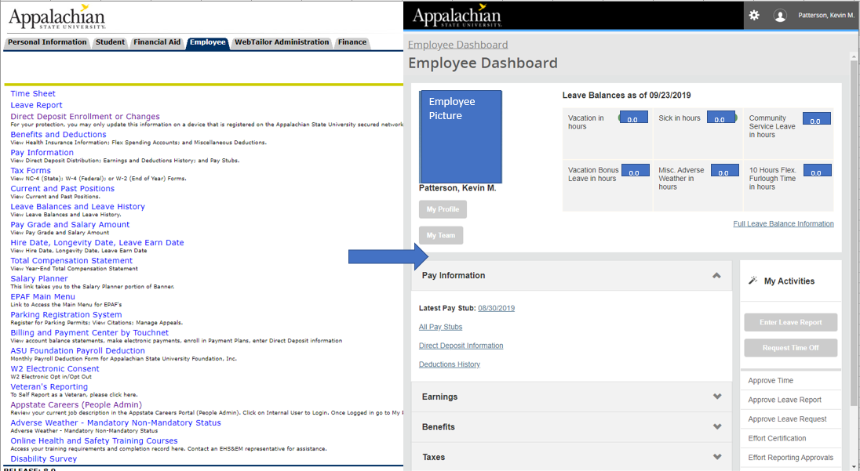

Where can I find Banner 9 Employee Self Service?
You can find the link to "Banner 9 Employee Self Service" on the https://appleap.appstate.edu/system-access page. The green highlighted link below is the new self service you should begin to use. The red highlighted link is the one we are moving away from.
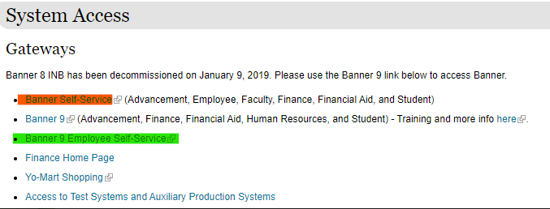
How does it affect me?
Probably the most used aspect of self service is time entry and approval. It looks and acts a lot differently than Banner 8, so if you need a little guidance, help videos are available here: https://payroll.appstate.edu/web-time-entry. However, most of the other items in the "employee" tab can now be found in Banner 9 Employee Self Service as well. It's a completely new layout that puts much more of the information from that tab on to the screen at once. It will also automatically adjust to different screen sizes making it easier to use on a tablet or phone.
What is not happening?
Currently this only affects most of the items found on the "employee" tab of Banner Self Service. The other tabs' items will be released in the future. Also note that the "employee" tab from Banner 8 Self Service will not be removed at this time. So for now, if you hit a road block you can still log into the old Banner 8 version (first link here). But please begin to using Banner 9 Self Service. The old version will go away once all functionality has been released in Banner 9.

